Hello, TA, Professor:

Thank you for your time and efforts through the whole sememeter and I am really grateful for it. But I do think there are some mistakes made on the grading of this test.

For question 1b i should not get deducted points because the idea i show this is exactly the concept which is shown in the slides. The question asks for one methods and methods work, thus i should get full credits on this problem

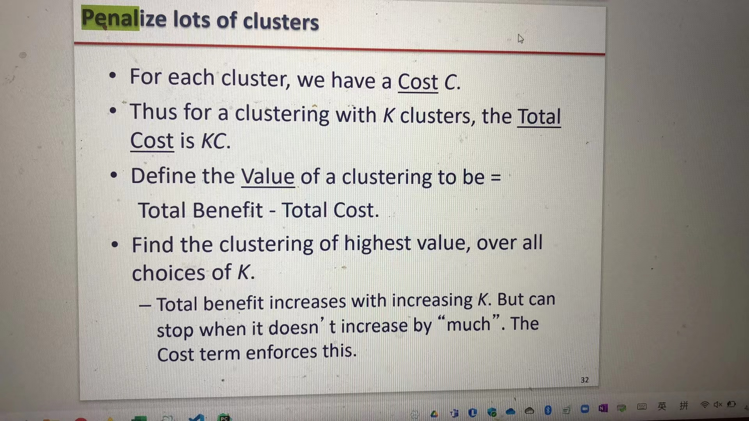

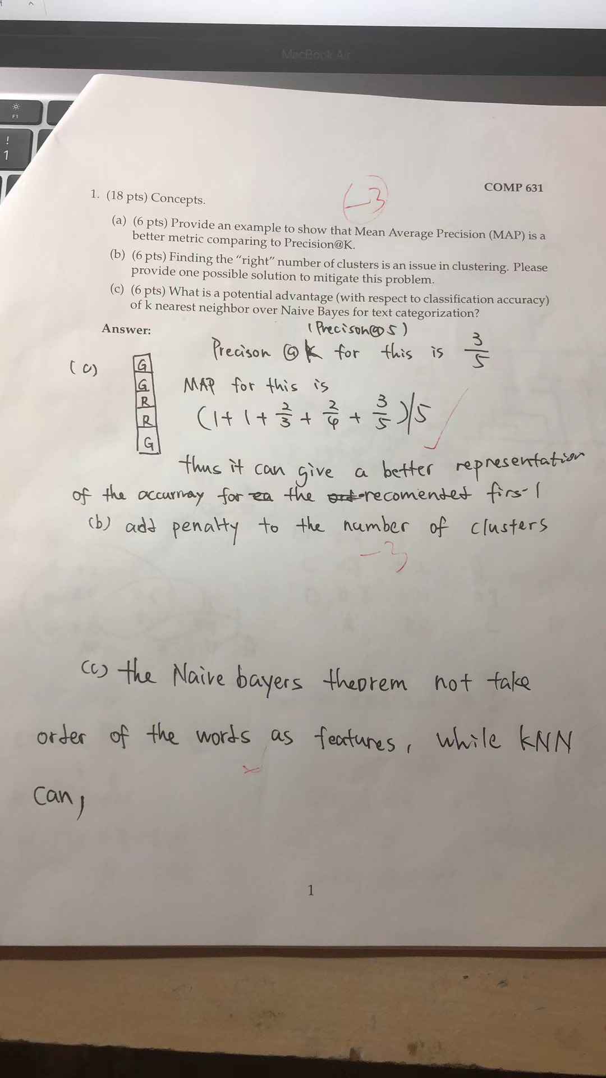

For question 2, i follow all the instructions in the question, it is not fair to disregard my work and deduct points in the whole exam, if i have the time on question 2 , i will have more time on the

question 3, i hope you can reconsider the decision to disregards the whole question, i would be lieve it a better and fair solution to award all students full points on question 2.

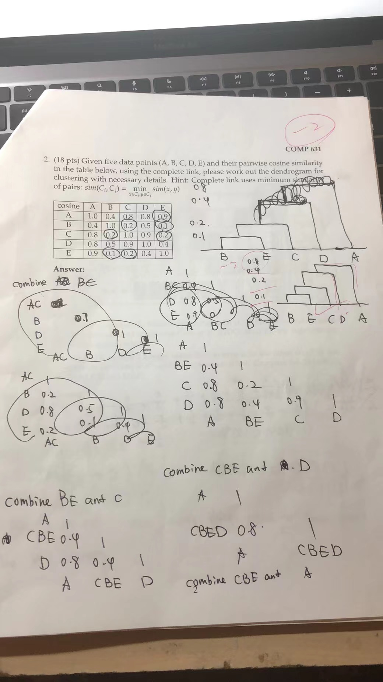

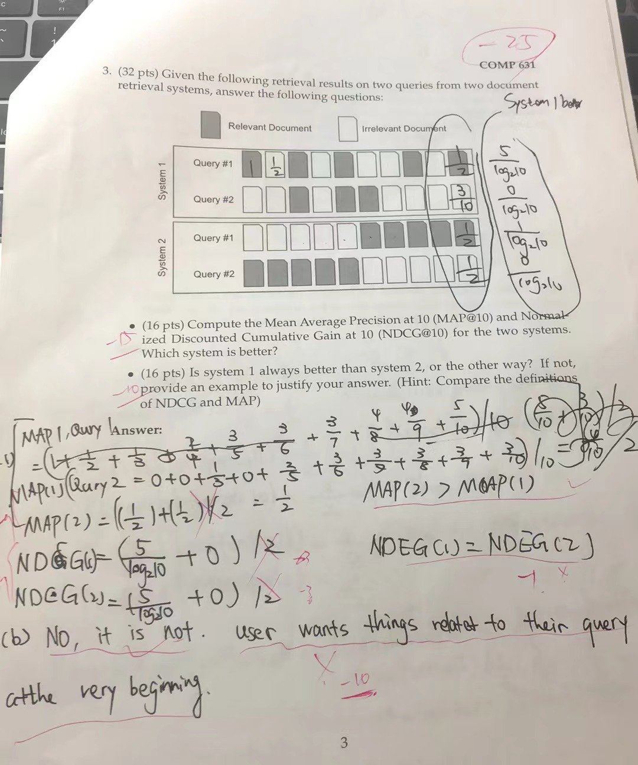

For question 3

I show the main concept of ndcg and map calcualtaion, i cannot write it out due to the lack of time which is consumed by question 2.

For question map part, there is almost no way to calculate the whole number amount by hand in such short of time, i should not get deducted for this part

But i do show the concept of how to claculatae ndcg , it is not fair to deduct almost all the points for it.

Also for 3b, i show the answer that the advantage of the system that in precision way one system might better , in ranking way the other system is better. Which is why we us map and ndcg, thus i don’t think get these points deducted

No regrade request for question 4

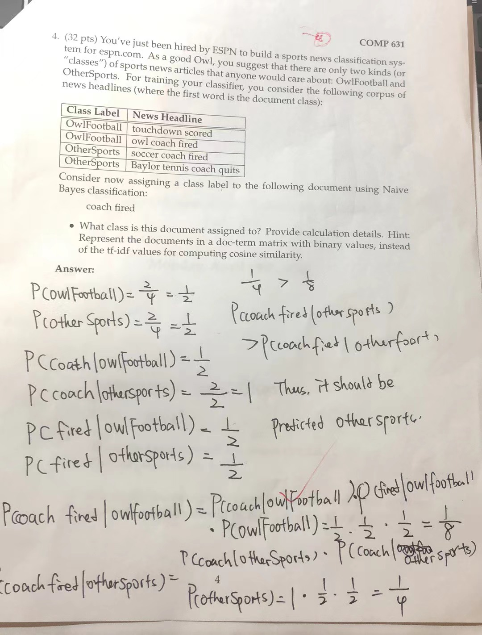

I don’t think cancel out the question will be a fair method for all students, especially in the test which we will have an opportunity cost to put time question 2 i will not have enough time for question 3. If you cancel the problem out, my time end efforts during the time will be a total waste.

Thank you again fo your time reading this regrade request. I really appreciate it. I went through some medical emergencies at the morning before the test, i literrally rushing from the methodist hospital emergency department to the classroom to complete the test.

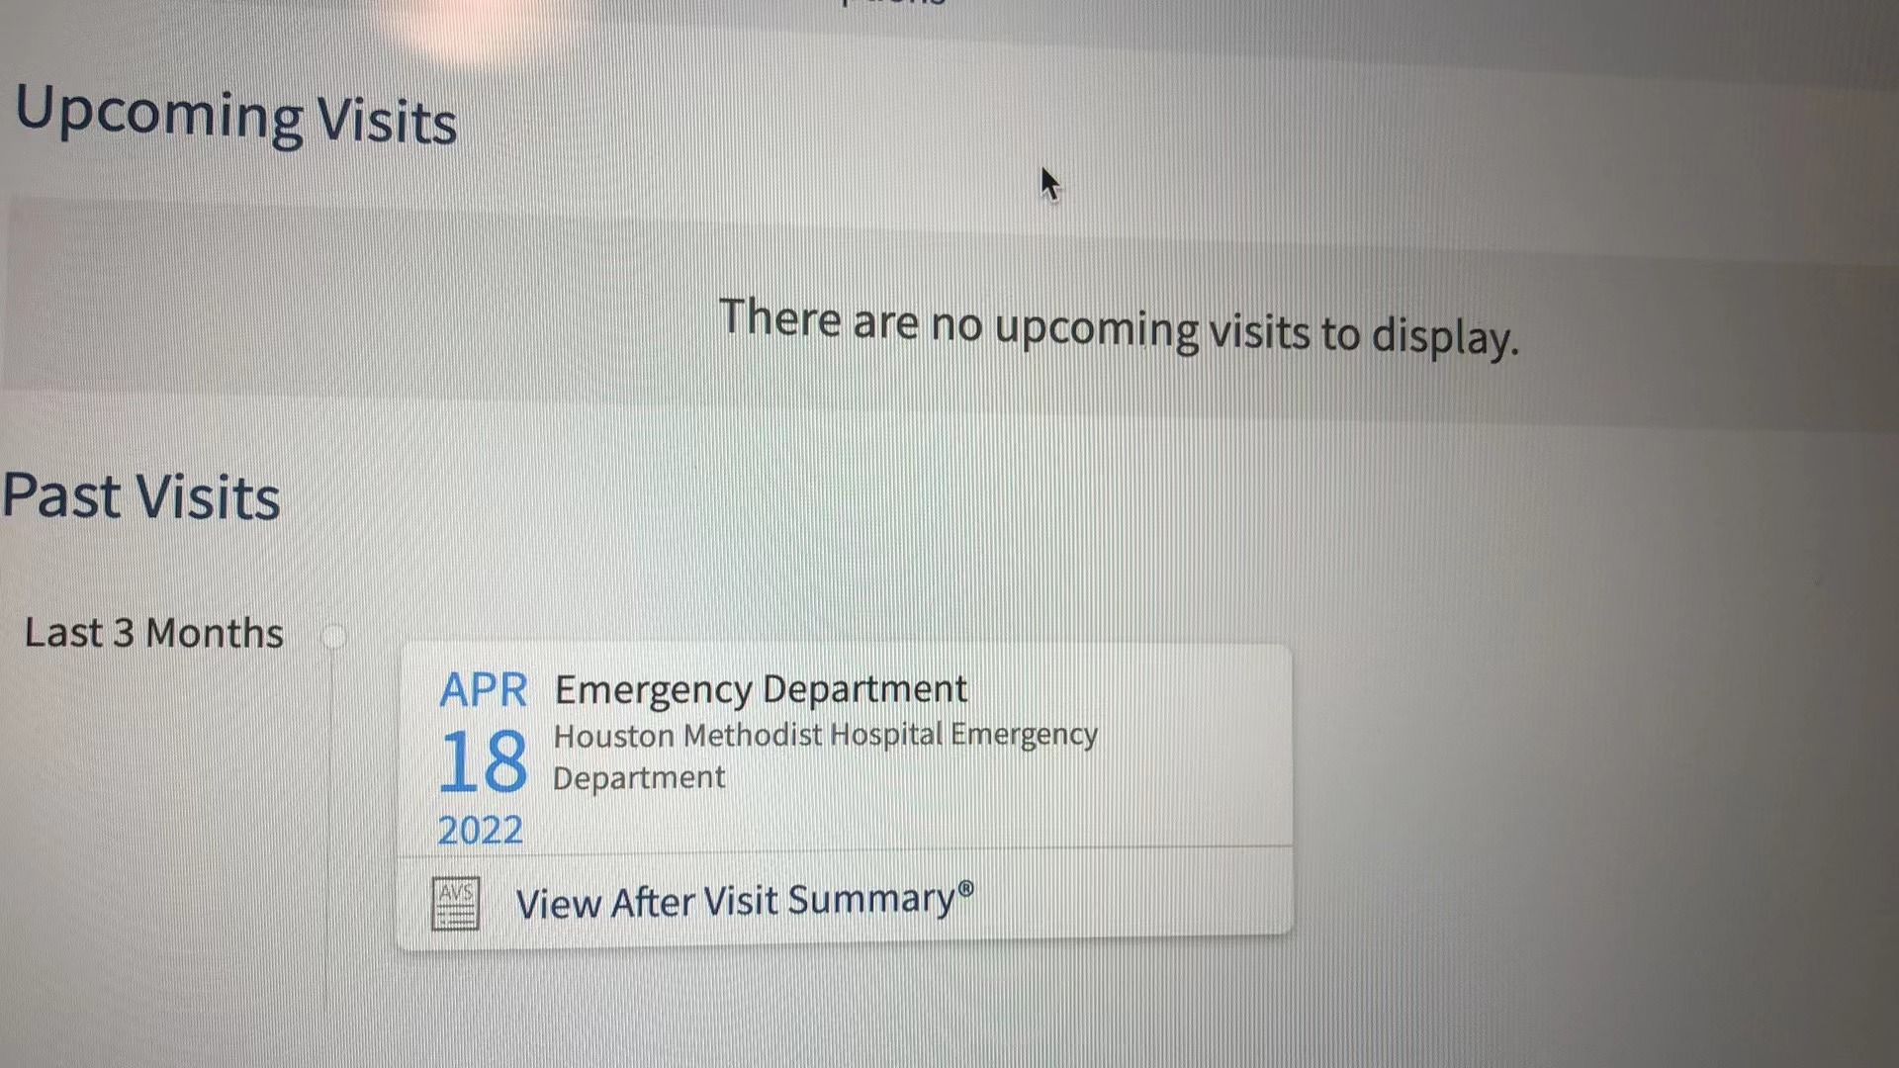

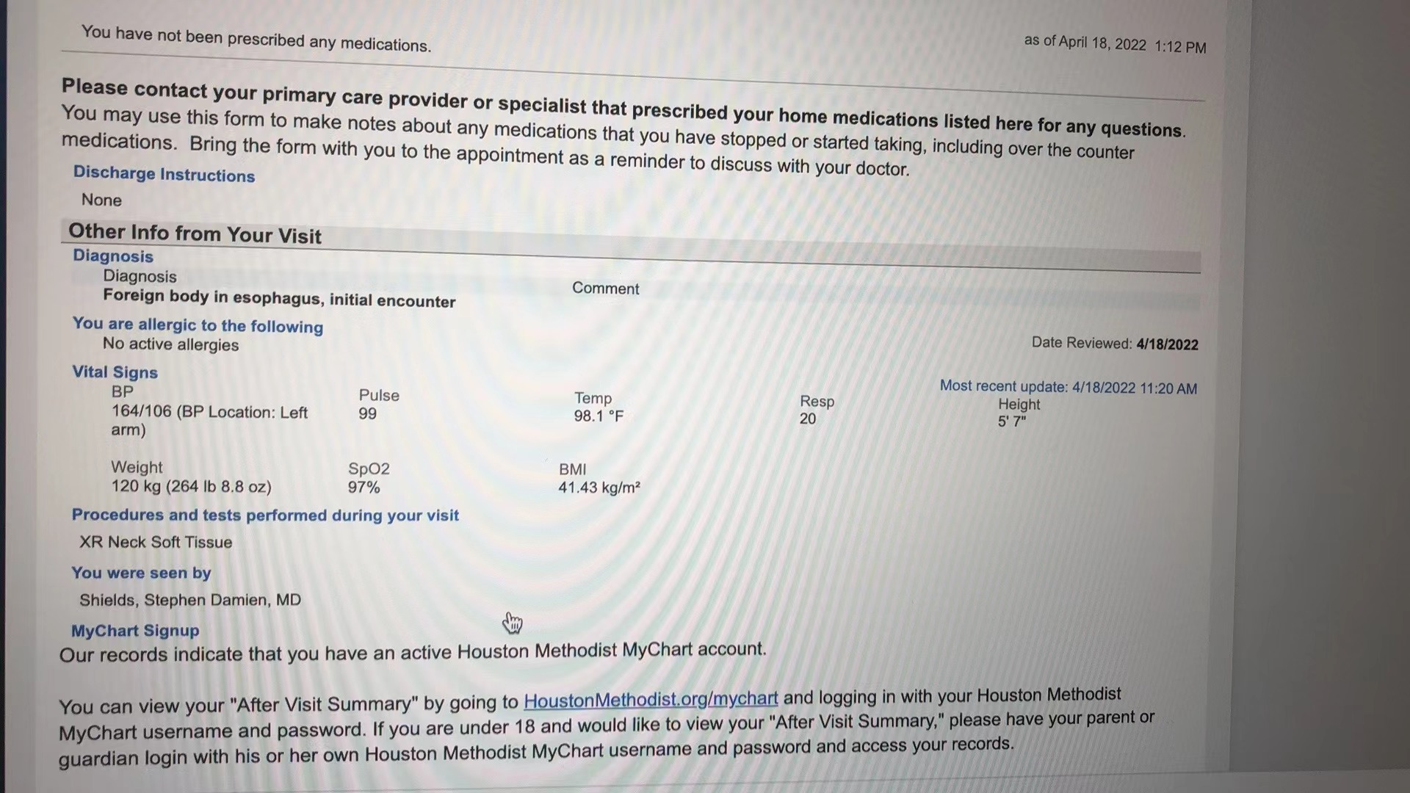

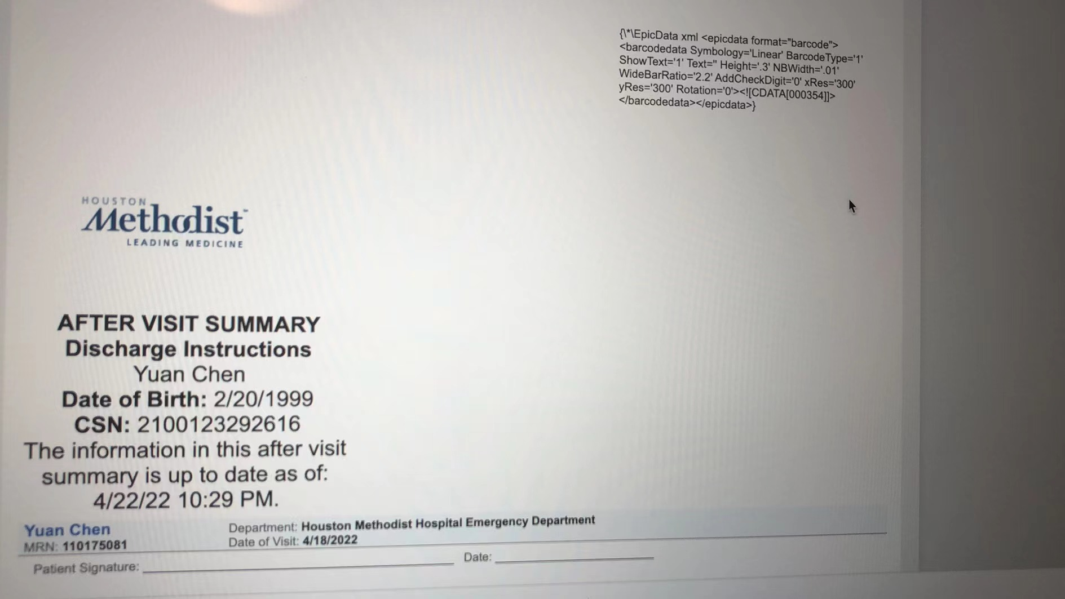

Thank you for your time

Best wieshes

Yuan Chen

yc149@rice.edu